“Zimbabweans failed by Zimbabwe”
The Zimbabwean Dispensation Project

Figure 1: Long queues wait in the sun outside the Wynberg Home Affairs Office

Report prepared by: PASSOP
(People Against Suffering, Oppression and Poverty)

March 8th, 2010


Index

1) Executive Summary p. 3

2) Background of the ZDP p. 5

3) DHA Office Wynberg p. 6

  - Capacity p. 7

  - Access to information p. 8

III. Requirements p. 9

4) Zimbabwean Consulate, Bellville p. 9

5) Conclusion p. 12

1. Executive Summary

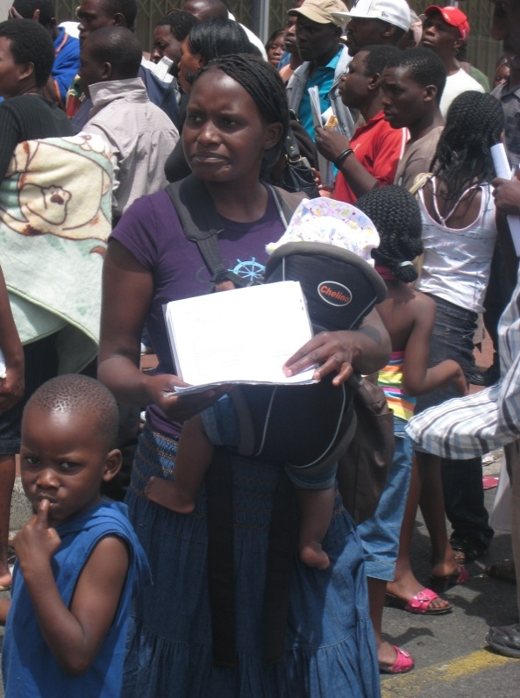
PASSOP was the only organisation that consistently monitored the implementation of the Zimbabwean Dispensation Project (ZDP) in the Western Cape throughout the full lifespan of the project. PASSOP embarked on its monitoring on the day the ZDP implementation began, the 20th of September, and completed its monitoring on December 31st, the ZDP’s final day. Due to limited funding, PASSOP was unable to maintain a continued presence at all Department of Home Affairs (DHA) offices. Thus, we focused our monitoring on the Wynberg office, as it was the busiest. We also conducted random site visits and received reports from the Paarl and George offices.

The ZDP’s implementation in the Western Cape was relatively effective compared to the implementation in other regions. By the end of the day on December 31st, all those in the queue had been served. In fact, the department was able to serve everyone in the queue every day for the week leading up to the 31st. We did not witness any instances of corruption among department officials and, as a whole, the queue management worked. Hence, one must recognise and commend the hard work, patience and dedication of DHA officials who worked long and hard hours under immense pressure to serve as many applicants as possible in the time provided. It is also worth noting the transparent and constructive manner in which the officials worked with civil society and NGO’s, providing necessary information and explanations to our monitors when needed.
Figure 2: Mother with baby queuing in Wynberg
Nationally, the DHA received 275,762 applications in just over 3 months, an impressive number. In all these regards, the implementation of the ZDP has exceeded our initial expectations. The repeated calls for the extension of the deadline, which were covered by media, created a certain sense of false hope among Zimbabweans who had not yet applied, and our monitors were frequently asked if the deadline would be extended. Although the DHA held firm on its deadline, it made certain concessions, such as removing the Zimbabwean passports as a requirement for application and accepting applications from people who did not have the full requirements. Although these concessions were implemented very late, only in the last ten days, they did considerably increase the number of applications that were received.
However, the project’s short and strict lifespan placed its implementation under immense pressure. This inevitably led to several shortfalls, including a shortage of accurate information and difficulty in both internal and external communication about changes to the requirements. It is a concern that the frequent loosening of the rules and regulations of the ZDP was not communicated extensively enough. This surely reduced both the overall number as well as quality of the applications. For example, it was only announced in mid-December that Zimbabweans could apply for the ZDP even if they had not yet received a passport. This contributed greatly to the bottleneck in the last two weeks of the project, when about half of the over 275,000 applicants rushed to submit their applications.
We believe that the success of the ZDP will ultimately depend on the quality of the adjudication process. It is important that all applicants are provided with an opportunity to produce any documents that may be missing in their applications and that all legitimate applicants are given permits.
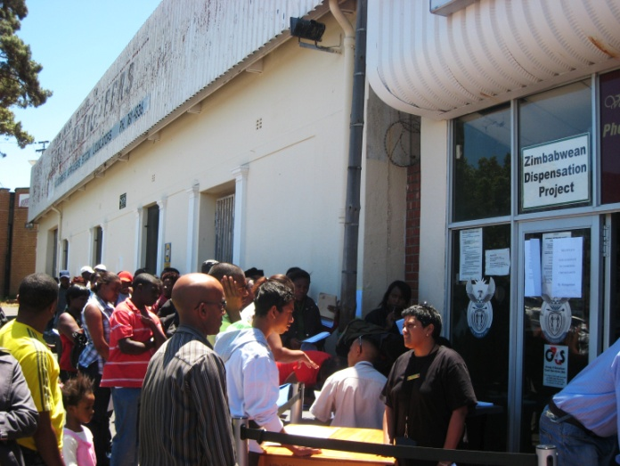
Another serious hindrance to the application process was, and continues to be, the issuance of passports by the Zimbabwean authorities. While the South African DHA is not charging a cent for the permits, the Zimbabwean authorities have been charging an exorbitant R750 per passport application. The high passport fees have led many parents to apply only for work permits for themselves and neglect applying for their children’s study permits. In addition, only a fraction of the tens of thousands of passport applications have been processed after four months. Passports will be needed for permits to be issued, and the number of Zimbabweans needing new passports is extremely high—over 60,000. The DHA had undertaken to complete the processing of all applications by the end of June, but later extended this to the end of July due to the Zimbabwean government’s failure to deliver passports. The South African DHA has announced that they intend to lift the moratorium on deportation of Zimbabwean nationals in August.
Figure 3: Large numbers of Zimbabweans queuing in the sun outside Wynberg DHA Office

Finally, during the ZDP, PASSOP monitors uncovered several cases of abuse and intimidation by security officials at the Zimbawean Consulate in Bellville, which ultimately led to criminal charges of assault against the head of security. The courts have released him on bail as they deliberate the merits of the case. The approach taken by the Zimbabwean government appears to fluctuate between one of indifference and one of violence.

2. Background of ZDP

The South African DHA officially launched the “Zimbabwean Dispensation Project” (ZDP) in September 2010, shortly after it announced that the moratorium on the deportation of undocumented Zimbabweans would be lifted on January 1st, 2011. According to the DHA, the ZDP was intended to provide undocumented Zimbabweans in South Africa the opportunity to legalize their stay by obtaining relevant permits by the 31st of December. The project predominantly targeted Zimbabweans who are in South Africa for economic reasons and in pursuit of improved livelihoods, rather than those seeking asylum. In the Western Cape, the project was planned to run from three separate Home Affairs regional offices in the Western Cape Province: Cape Town, Paarl and George. However, due to renovations to the Cape Town office (Barrack Street), the Wynberg office was used as an alternative.

In order to obtain a work permit through the ZDP, applicants were required to present a valid Zimbabwean passport and a letter from their employer. However, since many Zimbabweans are undocumented, they did not have a valid passport. They were therefore required to apply for a passport at the Zimbabwean consulate in South Africa before they could apply for a work permit under the ZDP.

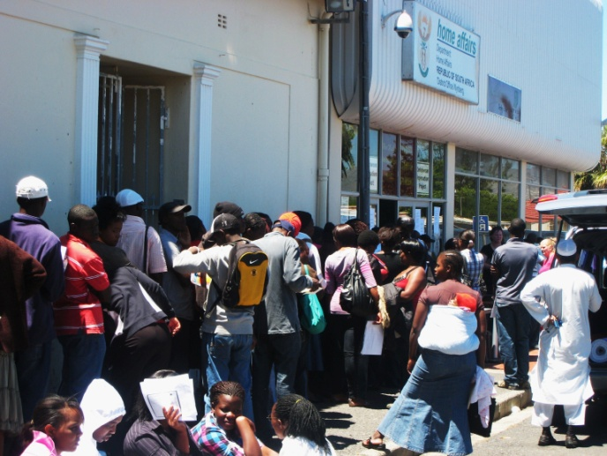
Because the proposed lifespan of the ZDP was just four months, it was clear from the beginning that it would be imperative for both the Zimbabwean Consulate and the South African DHA offices to operate efficiently and process each applicant in the quickest time possible, as anyone not processed could be at risk of deportation. To this end, the Government of Zimbabwe (GoZ) announced that it would be decentralizing the issuing of passports from Gauteng to all the nine Provinces in South Africa. Hence, in mid-October, the GoZ opened a Consulate at the South African DHA offices in Bellville.

However, this left Zimbabweans without passports in this province with only two and a half months to be processed by both the Zimbabwean Consulate and then Home Affairs. In mid-December, two weeks before the deadline, the Department of Home Affairs realized that the Zimbabwean consulate would not deliver anywhere close to the required number of passports and decided to accept permit applications with a receipt of a passport application. The DHA again widened the net in the last few days by allowing Zimbabweans to apply for permits even without passport applications. In addition, the department removed fingerprinting as a process requirement for the last few weeks, in order to accelerate the permit application process. Complaints from civil society were justified, as they were mainly based on concerns which were later addressed; in particular, complaints were lodged concerning the failure of the Zimbabwean Consulates to process many passport applications within the promised 6 week timeframe, or even to do so in a timely or efficient manner.
Figure 4: The queue in Wynberg in October

Before going into detail about the findings of the monitoring efforts at the Wynberg DHA Office and the Bellville Zimbabwean Consulate, it must be noted that the ZDP excluded, either directly or indirectly, a considerable group of Zimbabweans in South Africa. For example, many seasonal workers who are in South Africa for only several months, people whose employers refused to write letters, people who could not afford the R750 passport fee on such short notice, people who thought they couldn’t apply because they didn’t have a passport and traveled back to Zimbabwe (before the passport requirement was dropped in mid-December), people who are not allowed to leave work for two consecutive days (as was necessary to get applications into the consulate), and—until the last three days (when most restrictions were dropped)—many self-employed Zimbabweans (such as traders). The ZDP also excluded people who are currently unemployed or housewives and househusbands.

The majority of these cases could be easily addressed by an additional process of documentation (after assessing the ZDP process) for individuals who were turned away before requirements were relaxed and who may not have been informed of these changes either by the department or through available mediums of media.

3. Department of Home Affairs Office in Wynberg

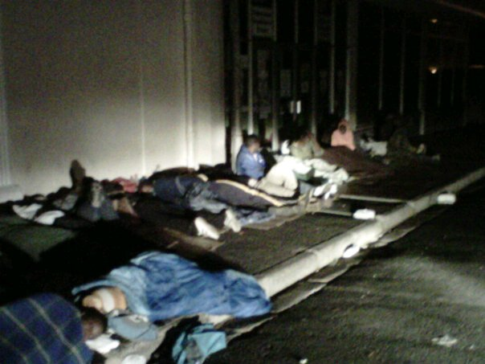
PASSOP undertook to monitor the implementation of the ZDP in the Western Cape when the project was first announced. However, due to funding constraints, we were not able to consistently monitor all three Home Affairs offices, and decided to focus on the busiest office in the province, the Wynberg office. We visited the office at least three times a week beginning in early September. We were forced to rely on only a few reports and visits to the other two DHA offices in the province (in Paarl and George). It appeared that the volume of applications was by far the largest at the Wynberg office.

It seems that issues in the Western Cape, outlined below, were minor in comparison to those reported from DHA offices in Gauteng and other provinces. There were reports at various Home Affairs offices in Gauteng of widespread disorder and Zimbabweans being beaten up and subjected to abuse while waiting in the queues. Thankfully, such situations were avoided at the three locations in the Western Cape, though the queues were long, and people sometimes had to sleep outside the offices overnight in order to apply the next day.

Over the past three months, we developed a good working relationship with the staff at the Wynberg Home Affairs office.The officials provided answers and information to inquiries from our monitors, and, when there was pressure, our staff provided assistance to the Department in crowd control, information dissemination, and ensuring that the vulnerable were prioritized. In the final two weeks of the project, our monitors attended the offices daily and assisted by managing queues and providing translations to Shona.

There are several factors we have found that severely constrained and hampered the implementation of the ZDP, including the capacity of the office, access to information and the stated requirements, which will be discussed below.

I. Capacity
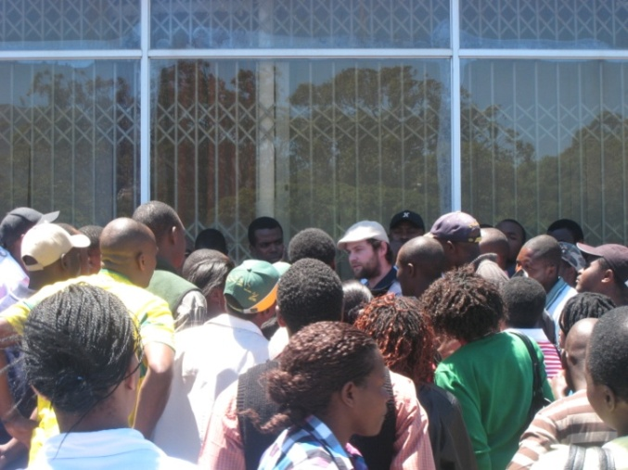
Since the launch of the ZDP, the number of Zimbabweans applying at the Wynberg offices has consistently stretched office capacity. The excessively long queues were managed by setting up an indoor and outdoor queuing system. As a whole, this system worked, although it did mean that there was widespread frustration amongst people who had to wait the better part of the day outside in the sun. Fortunately, more significant problems, such as corrupt agents selling forms or pushing people to the front of the queue, were largely avoided. Thus, as a whole, the application process was fair, including attempts to achieve gender balance and a transparent process of allowing preference to mothers with babies, as well as elderly and vulnerable people. In managing the large queues, DHA officials exercised patience while under huge pressure from a large number of people in the queues who frequently expressed their impatience, distrust and frustration.
Figure 5: PASSOP Director Braam Hanekom addressing the crowds
Despite these efforts, however, the numbers were often simply too large for the Wynberg DHA office to cope with. Our monitors reported over two hundred people queuing outside on any given day from September through November. The numbers jumped to around 500 on an average day in December. If they didn’t spend the night outside on the pavement, applicants arrived very early in the morning (often as early as 4am), and most queued for the entire day. We believe that the abundance of public transport (with a train station and bus and taxi ranks) in Wynberg avoided larger numbers from sleeping outside. In most cases, particularly towards the last few weeks of the ZDP, applicants stated that they had to come to the office on consecutive days since there was still a backlog of people from the previous day. According to our data, over 80% of Zimbabweans in our sample, who had managed to submit an application, said they had been at the DHA offices on at least one previous day to apply for the ZDP.

The capacity concerns were, however, addressed by the DHA in December, following the Minister’s visit. The increase was most notable in the final week of implementation, when capacity was strongly reinforced. This meant that even though an average of over 1,100 applications were processed at the Wynberg office daily, the last week of the ZDP saw DHA officials serving everyone in the queues, sometimes working as late as 10pm. This hard work must be acknowledged.

II. Access to information
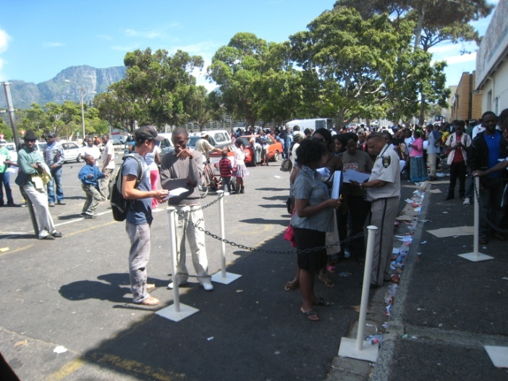
The lack of a clear or comprehensive provision of information was one of the most serious shortcomings in the implementation of the ZDP. Large numbers of applicants struggled to get hold of officials to find out a variety of information. Mainly, people wanted to know whether their permits were ready, what documents they needed, if they would be served that day and whether they could be given forms. We encountered widespread frustration, from those queuing, with the lack of access to information regarding what was needed to apply. Significant numbers of Zimbabweans contacted our office (averaging over 100 per week) throughout the ZDP in order to find out what was needed for their application. There was limited signage outside the DHA offices to inform people of the process, and the telephones were rarely answered, meaning that people often relied on hearsay and rumours to get information on what was needed for the application (for example, in the letter from the employer).
After conducting many interviews and having countless conversations with Zimbabweans, there is no doubt that this lack of clear information contributed heavily to the sense of confusion and frustration amongst Zimbabweans which has in turn, contributed to a sense of caution in completing the necessary steps to submit the permit application. Incorrect or partial understanding of information meant that many applicants had to return to the queue at the DHA offices on a number of different days with varying documents. This has had the troublesome effect of slowing down the entire application system and exacerbating the capacity constraints that were mentioned above.
Figure 6: PASSOP monitor David Burgsdorff answering questions, while the DHA officials address the queue

III. Requirements

Although the frequent application requirement changes benefited applicants as requirements became more inclusive and enabled more people to qualify, the way in which they were implemented was ad hoc and confusing. PASSOP monitors, and civil society in general, were not always kept informed by the DHA about new developments in the requirements, rules and procedures. The requirements were changed on numerous occasions, as the ‘net was widened’ gradually. At first, the ZDP was open only to applicants who had entered the country before May 1st, 2010. That requirement was dropped in mid-October, when the DHA decided that anyone with a valid passport and a letter from their employer could apply. In mid-December, people were allowed to apply without a passport, as long as they had a receipt of their passport application. Finally, in the last few days, even those without any documents were able to apply.

These many unforeseen and erratically announced changes contributed greatly to the huge bottlenecks in the last two weeks of December, as well as to a lot of the confusion throughout. There is surely a significant number of Zimbabweans who believed that they did not qualify, as they had no passport, or failed to meet the requirements. It is also noted that during the initial stages—when the requirements were more exclusive—an uncertain number were turned away from applying, although it is impossible to generate a reasonable estimate.

Not only were the eligibility requirements changed, but the rules and regulations of what documents needed to be submitted were also altered. We came across hundreds of cases in which applicants were rejected on the grounds of not including a tax clearance and company registration certificates, although these were not mentioned as requirements during the application process. Thankfully, the DHA has said that it will investigate the issue and that they will automatically review those rejections as such certificates were never required.

4. Zimbabwean Consulate, Bellville

Any informed assessment must identify that the biggest constraint and threat to the entire process was, and continues to be, the Zimbabwean government and its failure to produce passports for its citizens in South Africa.

In September of this year, the MDC South African leadership conducted an unannounced snap inspection of the Zimbabwean Consulate in Pretoria and concluded that the December 31st deadline was unrealistic, given the capacity of that office. Perhaps partially because of this, the GoZ announced in September that it would be decentralizing the issuing of passports from Gauteng to all the nine Provinces in the country, as mentioned above. The Consulate office in the Western Cape was consequently opened in Bellville in mid-October.

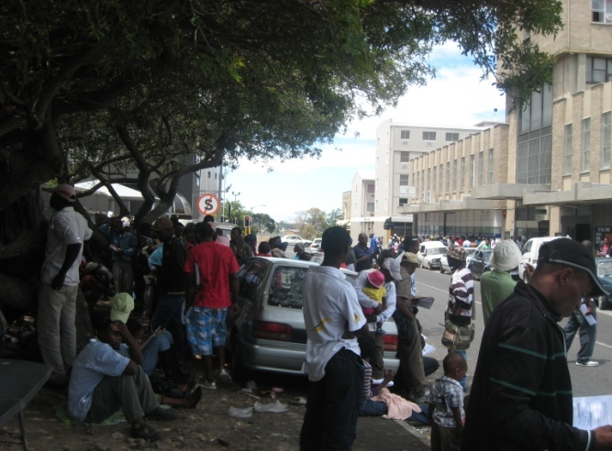
The Zimbabwean consulate in Bellville has, since it’s opening, been experiencing an extremely high demand for passport applications. Unfortunately, the application process was not always handled in an efficient and fair manner. Our monitoring efforts have uncovered several cases of dishonesty and fraud on the part of consulate staff. We have also witnessed intimidation and aggression—that was in part politically motivated—by security officials managing the queues both towards applicants and towards our monitors. In one case, a man was beaten to unconsciousness with a baton by the head of security. Such human rights abuses should not be allowed to happen in South Africa, and especially not right outside of a DHA office.

The failure by the Zimbabwean authorities to deliver passports led the South African government to begin accepting applications for the ZDP permits from Zimbabweans who had Zimbabwean consulate receipts showing that they’d applied. Later, the South African government needed to allow people who did not even have receipts to apply, because of the inability of the Zimbabwean officials to adequately meet the demand of large number of Zimbabweans wanting to apply.
Figure 7: Long queues outside Bellville Zimbabwean Consulate

In mid January the Zimbabwean consulate shut down its Bellville office, leaving thousands of frustrated Zimbabweans (many of whom had already paid) without passports. Although assurances were made that passport applications would be fast-tracked, and indeed this was given as the justification for the high R750 application fee, only a fraction of the passports that were applied for have been issues thus far.

Initially the Zimbabwean consulate promised to deliver passports within 10 days, then 6 weeks. In fact, this remains clearly stated on the Zimbabwean Consulate website: “Submission & collection through the Consulate cost R750.00 and are processed within 6 weeks”. Nevertheless, thousands of people have waited over three months to obtain their passports. There is concern that the Zimbabwean government may have “stolen” Zimbabweans’ money. One of the applicants explained to PASSOP monitor Hermien Arends:

“If someone tells you: ‘if you pay this amount of money we give you your passport’, and then you don't get it, it feels like cheating. Also, the second time I went back, their language was different than the language they used the first time. Once they got the money they treated us differently. They were not helpful anymore”.


Passports will be needed for permits to be issued, and the number of Zimbabweans needing new passports is extremely high, estimated to be at over 50,000. It is concerning that the Zimbabwean officials have discontinued their work at the Bellville office and (we are informed) at all the temporary offices they set up for the ZDP, despite the large number of passports that have not been delivered and large number of people who still need to apply.

This handwritten and misspelled sign placed outside the office suggesting people go to Johannesburg to collect their passports is unacceptable.

The South African minister of Home Affairs, Dr Nkosazana Dlamini-Zuma, said at a press briefing in mid-February, “We have a dependency we cannot do anything about. It depends on them", and "We are still awaiting passports from the applicants who are awaiting them from the Zimbabwean government". Ultimately, the South African Minster of Home Affairs organised a meeting in Pretoria to address their concerns on Tuesday the 23rd of February. The Zimbabwean co-ministers made promises to deliver all the passports by the end of July, forcing the South African Department of Home Affairs to extend their deadline by a month. It is not clear if they addressed the issue of provincial distribution of applicant’s passports. This will be a problem, as many applicants do not have the resources or time to collect the paid for passports in Guateng.
Figure 8: Sign at Bellville office

Other concerns which we are not certain were addressed include:

- There were instances when the Zimbabwean government selectively denied services to Zimbabweans who were seen as being politically aligned to the opposition;
- Zimbabweans with one parent who is from another country (Malawi, Mozambique, Zambia etc.) are being told they need to return to Zimbabwe to renounce citizenship from their non-Zimbabwean parent’s country.
Figure 8: Protest outside closed Consulate in Bellville in January
- Zimbabweans without birth certificates are being told to return to Zimbabwe to apply for them.
- Zimbabweans receiving passports whose names were spelled incorrectly in their printed passports.

The Zimbabwean co-ministers of Home Affairs also snubbed the Zimbabwean stakeholders forum meeting in January, which lead to much frustration. Zimbabwean human rights lawyer and advocate Gabriel Shumba complained, “I can't understand why they left a South African authority to take our questions relating to the Zimbabwean government. We wanted to engage them as our government ministers, but they couldn’t spare even one minute". This impunity by the Zimbabwean Government has been reflected throughout the ZDP process. Even the Director General of the South African Home Affairs Department, Mr. Apleni, willingly addressed the frustrated forum. It was reported that a highly positioned Home Affairs official expressed his feelings during the meeting, saying, "Your ministers don't even want to see you guys, why can't they address their own people instead of burdening us with damage control sessions".
5. Conclusion

PASSOP recognizes that the ZDP is a good first step towards regularising the stay of the many Zimbabweans currently living in South Africa. Through legalizing their status, Zimbabweans will be given a clear set of rights that should reduce the discrimination and exploitation that they are often subjected to by employers, landlords or officials, as well as give them the chance to access basic services. Beyond this, the ZDP will also serve to clear up the currently seriously over-burdened and backlogged asylum-seeker process.

The volume of ZDP applicants in the Western Cape Province was lower than in Gauteng, and therefore the implementation of the process was not as problematic as it was reported to have been there. However, even in this Province, the frequent changing of the application requirements, the lack of capacity of DHA offices and the inefficiencies of the Zimbabwean Consulate led to much confusion. The fact that over 275,000 applications were nonetheless submitted shows that Zimbabweans in South Africa wish to co-operate with the South African state and to live legally here while conditions in Zimbabwe remain difficult. The focus must now be on delivering a fair and carefully managed appeals system that takes into account the bottlenecks and rushed applications that occurred during the last two weeks of the ZDP.

A good sign that this is the intention of the DHA is that it has decided to implement a grace period and will not end the moratorium on deportations before August 1st. We will thus continue to monitor the appeals process closely in the coming months to ensure that it is fair, transparent and uniform across the board.
Finally, it is noted that in the South Africa cabinet statement on the 2nd of September 2010, in which the ZDP was originally announced, it was stated:

“As part of this agreement, the Zimbabwean Government has undertaken to issue documents to all their undocumented nationals”.

Thus, it was clear from the onset that the success of the ZDP process depended on the Zimbabwean government in fulfilling its side of the bargain. It cannot now deny that this is not the case. Unfortunately, as has become painfully clear in recent months, the Zimbabwean authorities have systematically failed in providing the necessary passports and thereby completely undermined the successful implementation of the ZDP. The Zimbabwean government’s lack of integrity, lack of communication with the affected Zimbabwean Diaspora, lack of engagement with and respect for civil society and a simple lack of delivery are to blame primarily for the current of the ZDP. The closure of the Bellville Consulate is a serious problem, because it is unaffordable for Zimbabweans to go to Johannesburg to collect their passports, particularly since there is no guarantee that passports will be ready. Even if the Zimbabwean government was to try its best, we anticipate that the huge volume of passport applications will take several months to be processed. Clearly Zimbabwe has failed Zimbabweans.

As time has passed, it has become clear that the South Africa DHA will either have to come up with an alternative solution for the issuing of permits or extend the moratorium on deportation and their deadline for processing applications. We hope that the spirit of engagement and flexibility that Dr Nkosazana Dlamini-Zuma and her team have shown through the process in recent months will be sustained.

Department of Home Affairs - Press statement regarding documentation of Zimbabweans-17 Jan. 2011.
To make matters worse, there is no refund policy, even when the applicant is prevented from applying after paying because of dual citizenship issues, as has happened and has been brought to our attention hundreds of times in recent weeks and months.
DHA minister at a press conference on the 22nd February, 2011.
Ibid.
Department of Home Affairs - Press statement regarding documentation of Zimbabweans, 1 September 2011
Ibid.
Department of Home Affairs, Zimbabwean Dispensation Project requirement sheet.
There have been many reports of disorder, huge queues and backlogs at the offices in Gauteng. See for example: http://www.timeslive.co.za/local/article680627.ece/Home-Affairs-chaos.
Langton Miriyoga, PASSOP monitor.
Langton Miriyoga, PASSOP monitor.
MDC, Press Conference, 21 September 2010, 17th floor, 20 Anderson Street, Johannesburg.
MDC, Press Conference, 21 September 2010, 17th floor, 20 Anderson Street, Johannesburg
Anthony Muteti, PASSOP monitor
Zimbabwean applicant, who is still waiting for his passport four months after having paid the R750. Statement retrieved on the 21st of February 2011.
DHA Minister Dlamini-Zuma
‘Zim ministers meet SA over passport crisis’, Alex Swift SW radio, 21st February 2011- online: http://www.swradioafrica.com/news210211/zimministers210211.htm
‘Mahodi and Makone ran away from scores of Zimbabweans in Pretoria over passports today’, The Zimbabwean, February 23, 2011 http://www.thezimbabwean.co.uk/index.php?option=com_content&view=article&id=34397:zef condemns-the-zimbabwe-consulates-insensitive-handling-of-passport-applications&catid=52&Itemid=32
Statement on Cabinet meeting held on the 1st of September 2010. Online retrieved at: http://www.gcis.gov.za/newsroom/releases/cabstate/2010/100901.htm

